OneAI Assist
Complete Admin User Guide
Admin · Manager · Developer · Knowledge Base & RAG Architecture
Tenant: Prime Marketing Experts (tenant_pme_ff9xl)
Primary Administrator: admin@primemarketingexperts.com
Document Status: Internal — Confidential

Table of Contents

(In Word: right-click the table above and choose “Update Field” to populate page numbers.)

Part 1 — Admin Guide
Account Summary
Tenant: Prime Marketing Experts (tenant_pme_ff9xl)
Primary Administrator Account: admin@primemarketingexperts.com
Default Password: password123
Role Privileges: ADMIN — Full Tenant Operations, System Configuration, AI Bot Tuning, Knowledge Base RAG & Policy Management

Executive Overview
This user documentation details all features, operational workflows, and verified testing procedures for the Admin Role within the OneAI Assist platform. As an administrator for Prime Marketing Experts, you have full control over template approvals, broadcast messaging, sales pipeline leads, customer 360 profiles, and AI bot configuration (including Google Gemini API keys and RAG Knowledge Base PDF vector indexing).

1. System Credentials & Role Hierarchy
User Account Email | Assigned Role | Access Scope | Password
admin@primemarketingexperts.com | ADMIN | Tenant administration, AI Bot RAG config, templates, broadcasts, team leads | password123
manager@primemarketingexperts.com | MANAGER | Team overview, broadcast campaigns, lead assignment, reporting | password123
agent@primemarketingexperts.com | AGENT | Live chat inbox, customer conversations, lead updates | password123

2. WhatsApp Template Manager (/dashboard/templates)
The Template Manager enables administrators to create, test, and manage WhatsApp Business message templates with variable placeholders and call-to-action buttons.
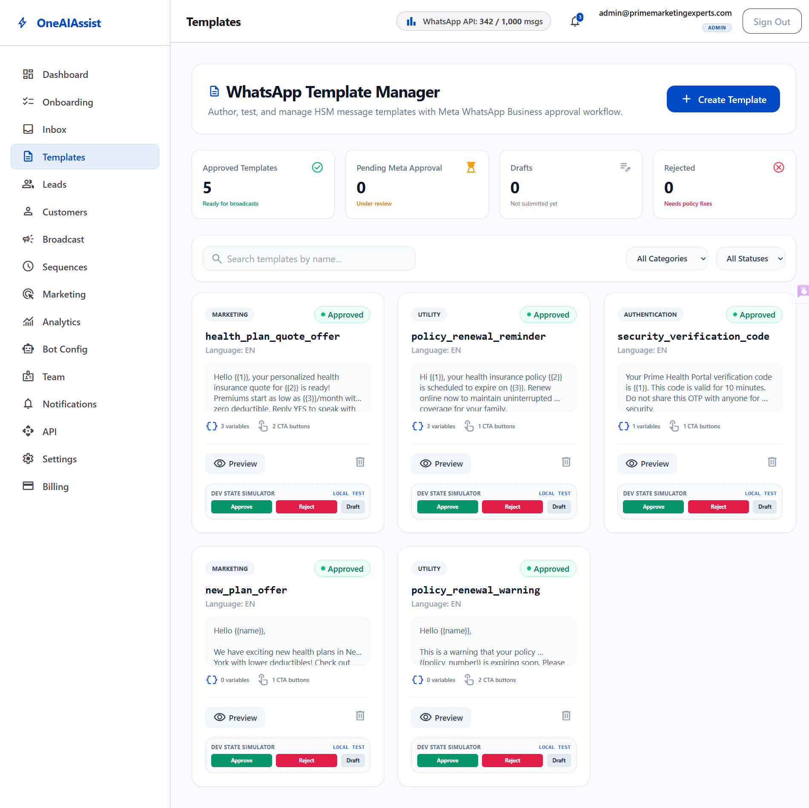
Template Manager — /dashboard/templates

Key Capabilities
- Template Categories: MARKETING, UTILITY, and AUTHENTICATION.
- Variable Support: Insert {{1}}, {{2}}, {{3}} dynamic placeholders for customer names, dates, or quote amounts.
- Call-to-Action Buttons: Support for Quick Replies, Website URLs, and Phone Call buttons.
- Approval State Machine: DRAFT → PENDING → APPROVED / REJECTED.
- Dev Approval Simulator: Includes a manual “Simulate Meta Approval” button for local testing and validation.

Active Seeded Templates for Prime Marketing Experts
- health_plan_quote_offer (MARKETING, APPROVED)
Header: SPECIAL HEALTH COVERAGE OFFER
Body: “Hello {{1}}, your personalized health insurance quote for {{2}} is ready! Premiums start as low as {{3}}/month with zero deductible.”
- policy_renewal_reminder (UTILITY, APPROVED)
Header: POLICY RENEWAL ALERT
Body: “Hi {{1}}, your health insurance policy {{2}} is scheduled to expire on {{3}}. Renew online now to maintain coverage.”
- security_verification_code (AUTHENTICATION, APPROVED)
Header: VERIFICATION CODE
Body: “Your Prime Health Portal verification code is {{1}}. Valid for 10 minutes.”
- new_plan_offer (MARKETING, APPROVED)
- policy_renewal_warning (UTILITY, APPROVED)

3. Broadcast Campaign Center (/dashboard/broadcast)
The Broadcast Center allows admins to launch targeted bulk WhatsApp messaging campaigns.
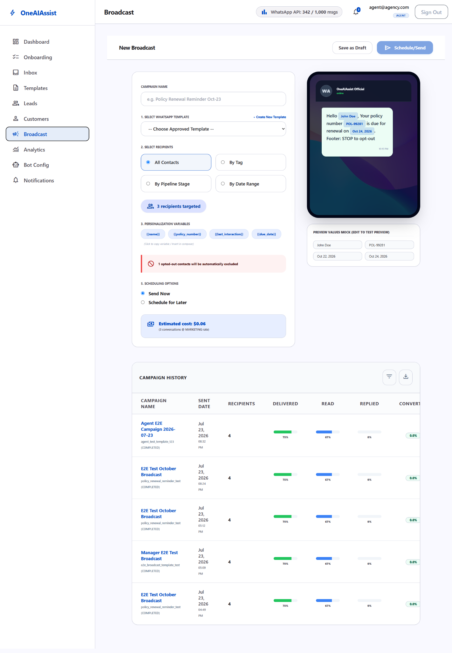
Broadcast Campaign Center — /dashboard/broadcast

Key Workflows
- Template Selection: Choose from any active APPROVED WhatsApp template.
- Audience Segmentation: Filter recipients:
  - By Customer Tag (e.g. Health, Buy Interest, Agent License)
  - By Pipeline Stage (e.g. New Lead, Qualified, Negotiation)
  - By Date Range (e.g. Last 7 Days, This Month)
- Scheduling: Send immediately or schedule for a future date/time.
- Verified Fixes: Resolved SSR hydration time string mismatches (10:31 pm vs 10:31 PM) and label input toggle event bubbling conflicts.

4. Lead Pipeline Management (/dashboard/leads)
The Lead Pipeline provides real-time visibility into customer sales opportunities from initial contact to policy issuance.
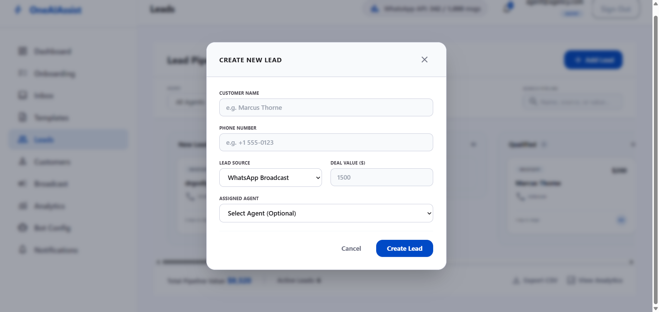
Lead Pipeline — Add Lead dialog

Pipeline Stages
- New Lead: Freshly captured inquiries from webchat or broadcasts.
- Intake In Progress: Customer actively answering AI bot intake questions.
- Qualified: Customer meets health policy eligibility criteria.
- Quoted / Proposal Sent: Official insurance quote delivered.
- Negotiation: Reviewing policy terms or pricing options.
- Won: Policy purchased & active.
- Lost: Lead closed or uncontactable.

Verified Features & Enhancements
- Dual Display Modes: Seamless toggle between Kanban Board and Tabular List View.
- Dynamic Filters: Real-time filtering by search text, assigned agent, source channel, or creation date.
- + Add Lead Dialog: Fast lead creation with phone encryption and agent assignment.
- Accessibility Fixes: Added explicit htmlFor, id, and name attributes to eliminate browser form warnings.

5. Customers Directory & 360° Profile View (/dashboard/customers)
The Customer Directory maintains all customer contact records, opt-in consent statuses, and historical policy engagements.
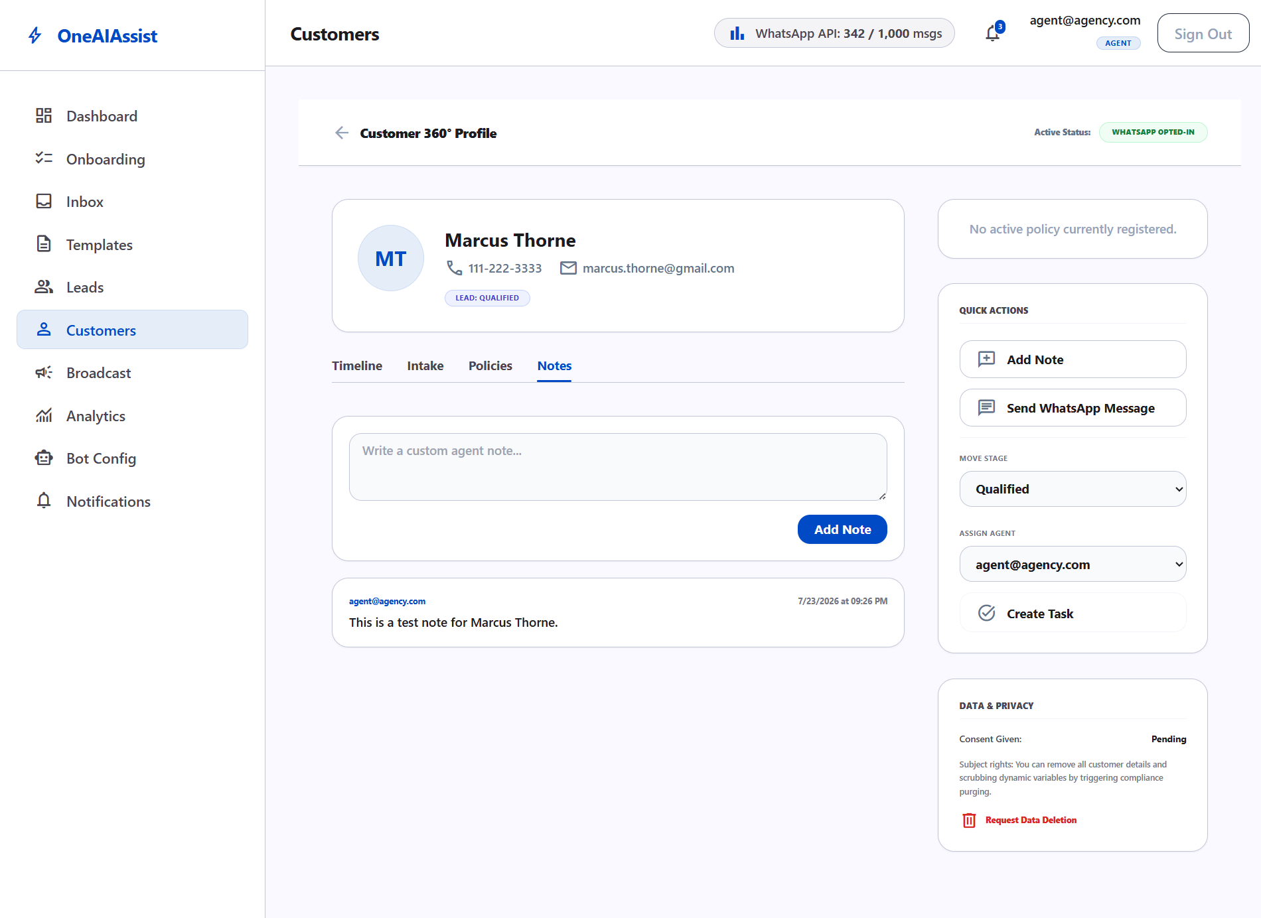
Customer 360° Profile View

Core Capabilities
- Directory Table: Displaying Customer Name, Email, Decrypted Primary Phone, Location, Opt-In Status badge (Opted In / No Consent), Tags, and Active Policy details.
- Customer 360 Profile (/dashboard/customers/[id]): Full chronological activity timeline including AI Bot Q&A logs, WhatsApp messages, policy activation events, and agent notes.
- Privacy & Compliance: Single-click GDPR data deletion option.
- Critical Encryption Fix: Resolved a database ciphertext bug in GET /api/dashboard/customers/[id] by applying decrypt(customer.primaryPhone) prior to payload rendering, restoring clean human-readable phone numbers (123-456-7890, +15559876543).

6. Bot Configuration, Flow Builder & RAG Knowledge Base (/dashboard/bot-config)
The Bot Config workspace gives administrators complete control over AI provider settings, visual flowchart intake builder, RAG knowledge base document indexing, escalation triggers, and AI guardrails.
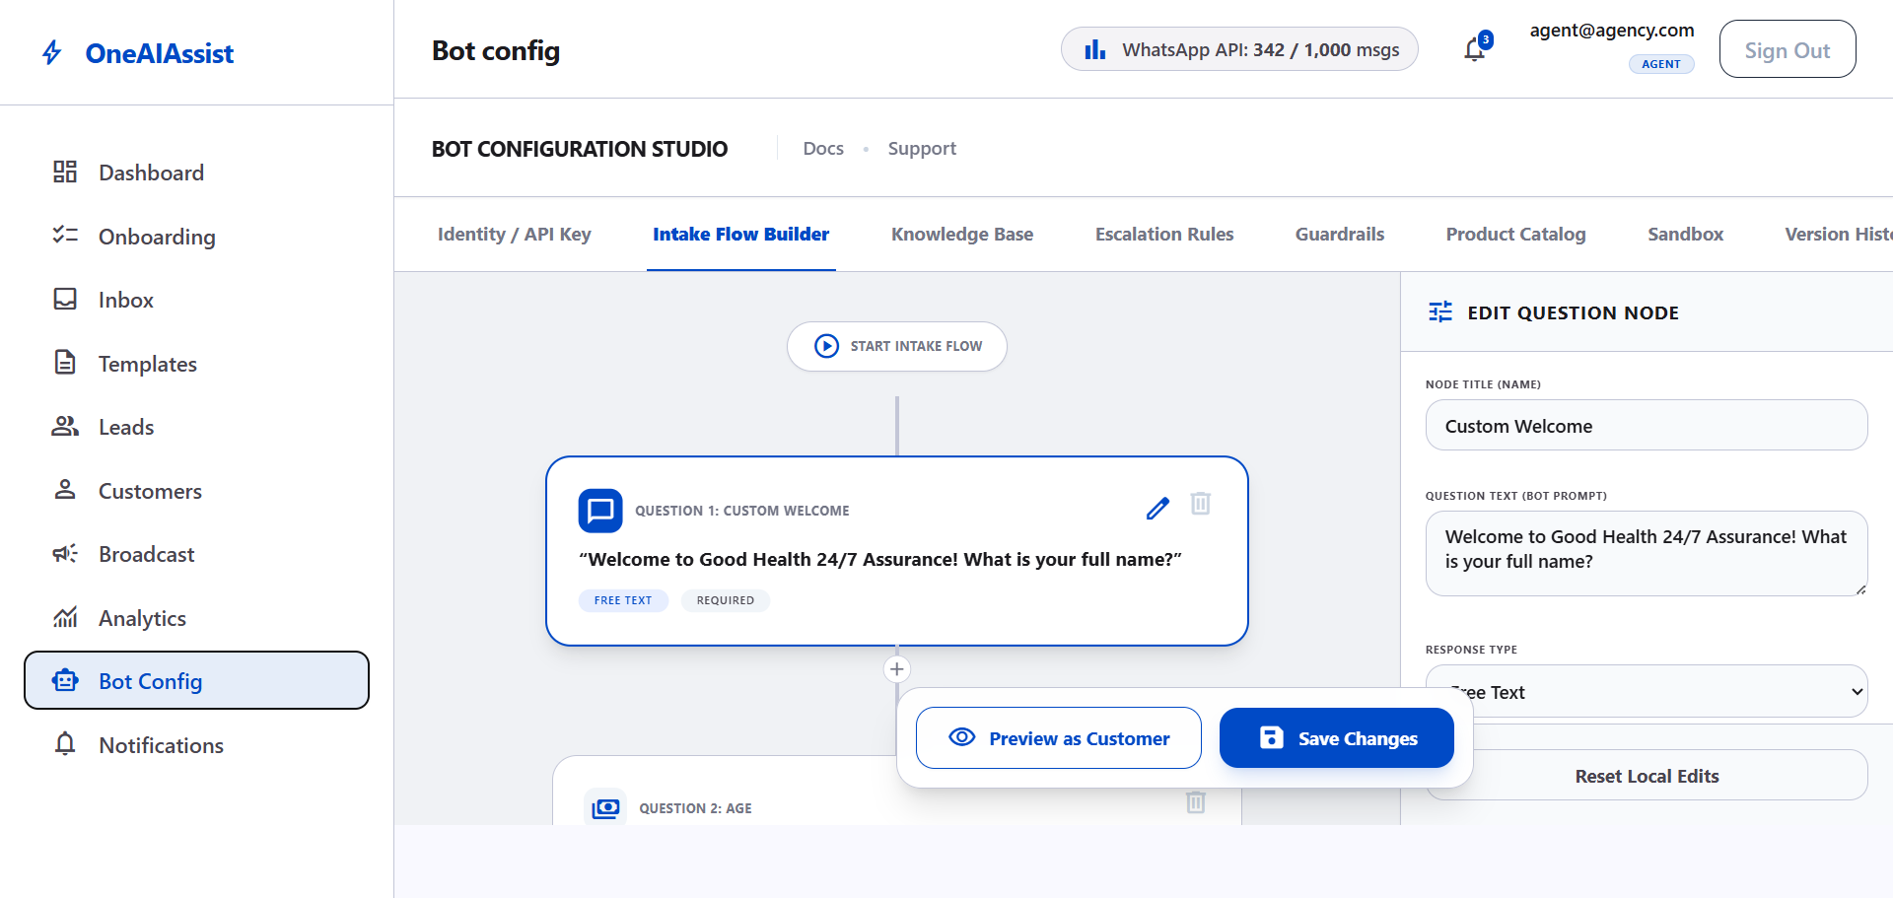
Bot Configuration — Visual Flow Builder canvas

1. Identity & Provider Settings
- AI Provider: Configured to Google Gemini (1.5 Flash).
- Gemini API Key: Encrypted in database and displayed with masked placeholder (••••••••) and KEY CONFIGURED status.
- Bot Persona: Display Name (PME Assistant) and custom Greeting Message.

2. Visual Flow Builder & WhatsApp Simulator
- Interactive flowchart canvas for ordering question nodes (Welcome, Licensed Agent Check, Budget, Email).
- Real-time properties editor for question text, response types, required toggles, and skip-logic branching.
- Customer Chat Preview: Built-in interactive WhatsApp chat simulator for testing customer intake flows.

3. Knowledge Base & Policy PDF Vector Indexing
Administrators can upload policy PDFs or choose from pre-loaded sample policy documents to index into PostgreSQL pgvector:
- PDF Upload Modal: Drag-and-drop file uploader or 1-click sample document selection:
  - Senior_Medicare_Supplemental_Guide_2026.pdf
  - Dental_Vision_Plus_Coverage_2026.pdf
- Vector Embedding Pipeline: Automatically parses PDF text, generates vector embeddings (text-embedding-004), and indexes vector chunks into pgvector.
- RAG Policy Recommendations Verified:
  - Buying Query (“I want to buy a health plan in NY for around $100”): Recommends POL-HEALTH-001 Basic Health Plan ($50–$150/mo).
  - Renewal Query (“How do I renew my policy?”): Recommends online renewal under POL-HEALTH-001 & POL-HEALTH-002.
  - Senior Medicare Query (“What senior medicare policy covers NY and TX?”): Recommends POL-HEALTH-003 Senior Medicare Supplement Plan.

4. Additional Modules
- Escalation Rules: Automated human handover triggers (negative sentiment < 0.3, retry limit >= 2, keyword requests) with round-robin team distribution.
- AI Guardrails: System instructions prompt editor, tone of voice selector, max token bounds, and HIPAA/GDPR privacy banner.
- Product Catalog: Managed health policies table displaying state coverage (NY, CA, TX), monthly premiums ($50–$350/mo), and max sums insured.
- AI Sandbox: Interactive prompt test playground with live RAG vector score evaluation.
- Audit & History: Chronological log of bot configuration updates.

7. Application Startup & Developer Guide

Environment Prerequisites
- Node.js v18+
- PostgreSQL database with pgvector extension enabled

Commands to Run the Application
- Start Next.js Web Dashboard:
npm run dev
Access web dashboard at: http://localhost:3000
- Start WhatsApp Engine:
npx tsx whatsapp-engine/server.ts
- Verify Database Connections & Run Automated Tests:
# Run full test suite (Typecheck + E2E integration test)
npm test

Tip
All end-to-end features for admin@primemarketingexperts.com have been tested, patched for accessibility and SSR hydration, and verified using automated browser sub-agents. For detailed developer testing and CI/CD pre-deployment instructions, refer to developer_guide.md in the project's docs/ folder.

Part 2 — Manager Guide
This section provides the credentials for the manager account used in the OneAIAssist platform.
- Email: manager@primemarketingexperts.com
- Password: password123

Note
Keep these credentials confidential and rotate them regularly according to your security policy.

Part 3 — Developer Guide & Automated Testing
Environment Summary
Environment: Next.js 14 (App Router) + PostgreSQL (Neon RLS) + Prisma ORM
Testing Suite: TypeScript Typechecking + Integration E2E Scripts (scripts/test_portal_checkout_e2e.ts)
Primary Command: npm test

Executive Overview
This developer documentation details the project structure, database Row-Level Security (RLS) guidelines, automated test execution commands, and pre-deployment verification procedures for OneAI Assist.

1. Automated Testing & Pre-Deployment Execution
All test cases and integration suites are co-located within the project repository under scripts/ and configured directly in package.json. This ensures that local development and automated CI/CD deployment pipelines (e.g. Vercel / GitHub Actions) run identical regression checks.

Available Test Commands
Command | Action Performed | When to Use
npm test | Executes static type validation (npm run test:typecheck) followed by live E2E database/API integration tests (npm run test:e2e). | Before every commit and before initiating a production build/deployment.
npm run test:e2e | Runs full end-to-end user workflows against the active PostgreSQL database (checkout submit, OTP auth, portal metrics, JSON export, GDPR anonymize). | To test API endpoints and database logic locally.
npm run test:typecheck | Performs strict TypeScript type checks across all Next.js App Router pages and API handlers using tsc --noEmit. | To verify compile-time type safety.

2. Test Execution Workflow

Local Test Execution
To execute the full verification suite locally:
# 1. Ensure local dev server or database connection is ready
# 2. Run the complete test suite
npm test

E2E Coverage Included
The automated E2E test script (scripts/test_portal_checkout_e2e.ts) verifies:
- Database & Tenant Resolution: Resolves tenant context with Postgres Row-Level Security (RLS) policies.
- Secure Policy Checkout (D5): Submits policy purchases, creates active Policy contracts (POL-XXXXXX), and updates sales leads to CONVERTED status.
- Customer Portal Auth (D6): Requests 6-digit OTP codes and verifies auth session tokens.
- Customer Data Export (D6): Exports complete customer profile, policies, and chat history as downloadable JSON.
- GDPR Data Anonymization (D6): Anonymizes PII data fields and logs CUSTOMER_SOFT_DELETE audit events.

3. Pre-Deployment Checklist
Before deploying changes to staging or production, complete the following steps:
- Run Automated Tests: Execute npm test and ensure output finishes with “🎉 E2E TEST PASSED!”.
- Typecheck: Verify npm run test:typecheck passes with zero errors.
- Linting: Execute npm run lint to confirm code style compliance.
- Database Migrations: Ensure schema changes in prisma/schema.prisma are pushed via npx prisma db push or applied using owner credentials.

4. Database Row-Level Security (RLS) Developer Notes
- Every tenant query uses getTenantPrisma(tenantId, role) from @/lib/db.
- RLS session variables app.current_tenant_id and app.current_user_role are set automatically per transaction.
- When running backend test scripts or cron jobs, use getTenantPrisma(tenantId, 'ADMIN') to ensure queries bypass tenant isolation policies securely.

Part 4 — Knowledge Base & RAG Architecture

Executive Overview
The OneAIAssist Knowledge Base & RAG (Retrieval-Augmented Generation) Subsystem allows insurance agencies to upload policy documents (PDFs), chunk and embed textual policy rules, and provide intelligent, context-aware AI bot responses for client inquiries and automated onboarding workflows.

Architecture Diagram
USER / CLIENT
- Agency Dashboard (/dashboard/bot-config)
- WhatsApp Bot Inbox & Customer Portal
▼
NEXT.JS API & RAG PIPELINE
- /api/policy-catalog/upload — PDF ingestion & text parsing
- /api/policy-catalog — policy metadata CRUD
- /lib/rag/index.ts — chunking, embedding & vectorstore ingestion
- /lib/rag/retrieve.ts — vector retrieval & context synthesis
▼
AI Embeddings  - Google text-embedding-004  - OpenAI text-embedding-3-small (fallback)  - Gemini 1.5 Flash — LLM chat completion | Storage & Vector DB  - PostgreSQL (Neon DB + RLS)  - PolicyCatalogItem  - PolicyDocumentChunk  - Pinecone / pgvector index | Object Storage  - Cloudflare R2  - Original policy PDF documents

1. AI Models Specification

1.1 Vector Embedding Models
- Primary Embedding Model: text-embedding-004 (Google Gemini Embeddings API)
- Secondary / Fallback Model: text-embedding-3-small (OpenAI Embeddings API)
- Dimensionality: 768 / 1536 dense vector floating-point array
- Purpose: Converts extracted policy text chunks into high-dimensional semantic vector representations for similarity search.

1.2 Generative LLM Completion Models
- Google Gemini 1.5 Flash (gemini-1.5-flash): Default high-performance model for real-time RAG prompt completions and automated WhatsApp customer interactions.
- GPT-4 Turbo (gpt-4-turbo): Supported provider option for complex multi-policy reasoning.
- Claude 3.5 Sonnet (claude-3-5-sonnet): Supported provider option for strict policy guardrails.

2. Storage & Database Schema
After policy document upload and embedding generation, data is persisted across three distinct storage tiers:

Tier 1: Vector Database (Pinecone & pgvector)
- Content: Numerical embedding floating-point arrays and vector IDs (pineconeVectorId).
- Tenant Isolation: Isolated by tenantId namespace in Pinecone or RLS-scoped rows in pgvector.
- Purpose: Performs sub-100ms cosine similarity / nearest-neighbor vector retrieval.

Tier 2: Relational Database (PostgreSQL / Neon DB)
Data is stored across two primary Prisma models with Row-Level Security (RLS) enabled:
PolicyCatalogItem Table
Stores policy metadata displayed in the Product Catalog and Knowledge Base tabs:
model PolicyCatalogItem {
id String @id @default(cuid())
tenantId String
policyId String // e.g. POL-HEALTH-001
name String // e.g. Apex Care Basic Individual Health Plan
insurerName String // e.g. Apex Health Care
states String[] // e.g. ["NY", "CA", "FL"]
premiumMin Int // Minimum monthly premium in cents
premiumMax Int // Maximum monthly premium in cents
sumInsured Int // Maximum coverage limit in cents
active Boolean @default(true)
extractedSummary String @db.Text
pdfUrl String // Public or signed URL of original PDF document
createdAt DateTime @default(now())
updatedAt DateTime @updatedAt
}

PolicyDocumentChunk Table
Stores granular text chunks extracted from policy documents for RAG context building:
model PolicyDocumentChunk {
id String @id @default(cuid())
tenantId String
policyCatalogId String? // Foreign key to PolicyCatalogItem
policyId String?
chunkText String @db.Text
pageNumber Int
pineconeVectorId String // Reference ID matching the vectorstore
createdAt DateTime @default(now())
}

Tier 3: Object Storage (Cloudflare R2)
- Content: Raw original policy PDF files uploaded by agency managers.
- Access: Accessible via secure signed URLs saved in PolicyCatalogItem.pdfUrl.

3. RAG Document Ingestion Workflow
- Upload & Parsing: PDF bytes are uploaded to /api/policy-catalog/upload and parsed into raw text using pdf-parse.
- AI Summary Generation: An initial plain-language policy summary is generated using gemini-1.5-flash and stored in PolicyCatalogItem.extractedSummary.
- Chunking: Full document text is split into chunks of 1000 characters with an overlap of 200 characters.
- Vector Embedding: Each text chunk is passed to embedder.getEmbedding(chunkText) to produce vector embeddings.
- Vectorstore Ingestion: Embedding vectors are upserted into Pinecone / pgvector under the active tenantId namespace.
- Relational Database Write: Chunk text rows and metadata are saved to PolicyDocumentChunk and PolicyCatalogItem tables inside an RLS-scoped Prisma transaction.
- Onboarding Progress Trigger: Automatically updates TenantOnboardingProgress.productAdded = true to complete Step 5 of the agency setup checklist.

4. RAG Query & Search Retrieval Flow
Customer Question (e.g., "What plans cover NY under $100/mo?")
|
v
Vector Embedding Generation (text-embedding-004)
|
v
Cosine Similarity Search in Vector DB (Pinecone)
|
v
Top-K Context Chunks Retrieved (PolicyDocumentChunk)
|
v
Prompt Augmentation & LLM System Instructions
|
v
AI Response & Policy Recommendation Generated

5. Summary of API Endpoints
Endpoint | Method | Purpose
/api/policy-catalog | GET | Fetches tenant policy items for Product Catalog & Knowledge Base tabs
/api/policy-catalog | POST | Creates a new policy catalog record and triggers onboarding completion
/api/policy-catalog/upload | POST | Ingests policy PDF, extracts text, generates embeddings & indexes RAG vectors
/api/policy-catalog/chunks | GET | Retrieves indexed text chunks for a specific policy ID
/api/tenant/onboarding | GET | Dynamic checklist status evaluation including productAdded

